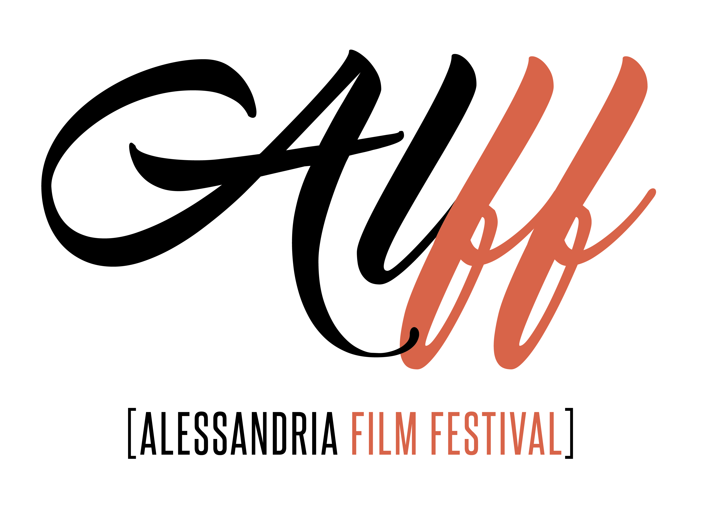

Regulation
Goals
Rising from the encounter between different people who want to share their passion for cinema, the Alessandria Film Festival aims to establish an enduring and stable event expanding the cultural activities programme in the city of Alessandria. The Festival's purpose is to provide a space for emerging and independent cinema, bringing out young filmmakers and promoting original stylistic and formal perspectives of artistic expression. The Festival is composed of the Feature and Short Film Competitions to which filmmakers can subscribe their works through the online submission form. In addition to that, different workshops and cinema lectures will open avenues of inquiry concerning “professions in cinema”, as they could be called. As far as it is concerned, the Festival will award the most deserving “cinema professional”, along with the usual prizes.

Festival dates
The first edition of ALFF will take place in Alessandria from 22 to 24 March 2019, (in three days).
Programme
The Festival is composed of two sections, the International Feature Film and International Short Film Competitions. In addition to that, presentations and lectures conducted by film critics as well as industry professionals. During the opening night a film will be introduced in the presence of a guest.
Concorso internazionale lungometraggi (International Feature Film Competition)
-The films are selected at the incontestable discretion of the Artistic Direction of the Festival.
- Fiction films and documentaries (starting from 50 minutes length) will be admitted to the selection only if completed after January 1st, 2018. The date of the film’s first public screening is determinant.
-The Artistic Direction will nominate a Jury composed of at least three personalities from the world of cinema, which will award the following prizes:

- Best Film;
- Special Jury Prize “I mestieri del cinema” (professions in cinema)
- Best Performer;

Concorso internazionale cortometraggi (International Short Film Competition)
-The films are selected at the incontestable discretion of the Artistic Direction of the Festival.
-The section is reserved for short films not more than 30 minutes in length completed after January 1st, 2018, without limitation regarding style or genre. The date of the film’s first public screening is determinant. Each filmmaker could submit no more than two films.
-The Artistic Direction will nominate an International Jury composed of
at least five personalities from the world of cinema, which will award the following prizes:
-Best short film -Special Jury Prize “I mestieri del cinema” (professions in cinema) - Best Performer

Film registration and deadline
Registration costs:
6 € for short films
10 € for feature films.
The official Festival registration form must be filled out online through www.filmfreeway.com . Copyright holders of the films who intend to participate in the Festival (in any section) must send a streaming link or upload a file following the procedures indicated on the entry form, along with the plot of the film and the filmmaker’s bio-filmography, by and no later than December 15th, 2018.
The shipping costs of all materials submitted for selection are to be covered by the entrants.
Exclusively for the films invited to the Festival: the Programming Office will send a request for complete documentation and provide a list of required material. Film and video prints which are invited to the Festival must arrive in Alessandria by and no later than February 15th, 2019, as per the instructions which will be provided by the Programming Office.

General rules
Foreign films will be screened in their original version with Italian subtitles. For films not in the English language, the producers are invited, if possible, to provide an English subtitled print.
The Festival Organizers will publish a general catalog of all the participating films. Shipping costs will be covered by the entrant, except when other agreements have been made with the Festival Organizers. These regulations have been drawn up in Italian and English. In case of dispute, the Italian version will be final. The Festival Organizers reserve the right to make decisions on matters not specified herein. A Selection Committee (with an advisory brief) made up of film experts will assist the Artistic Directorship in the scouting and selection of works for the Festival. The producers and distributors of all films selected undertake to make mention in their publicity and advertising materials (posters, press- kits, trailers, website, etc.) of the selection of the film for the Festival, by featuring the official logo which will be supplied by the Artistic Direction. The logo must not under any circumstances be modified or altered without the prior permission of the Festival.

